26-27
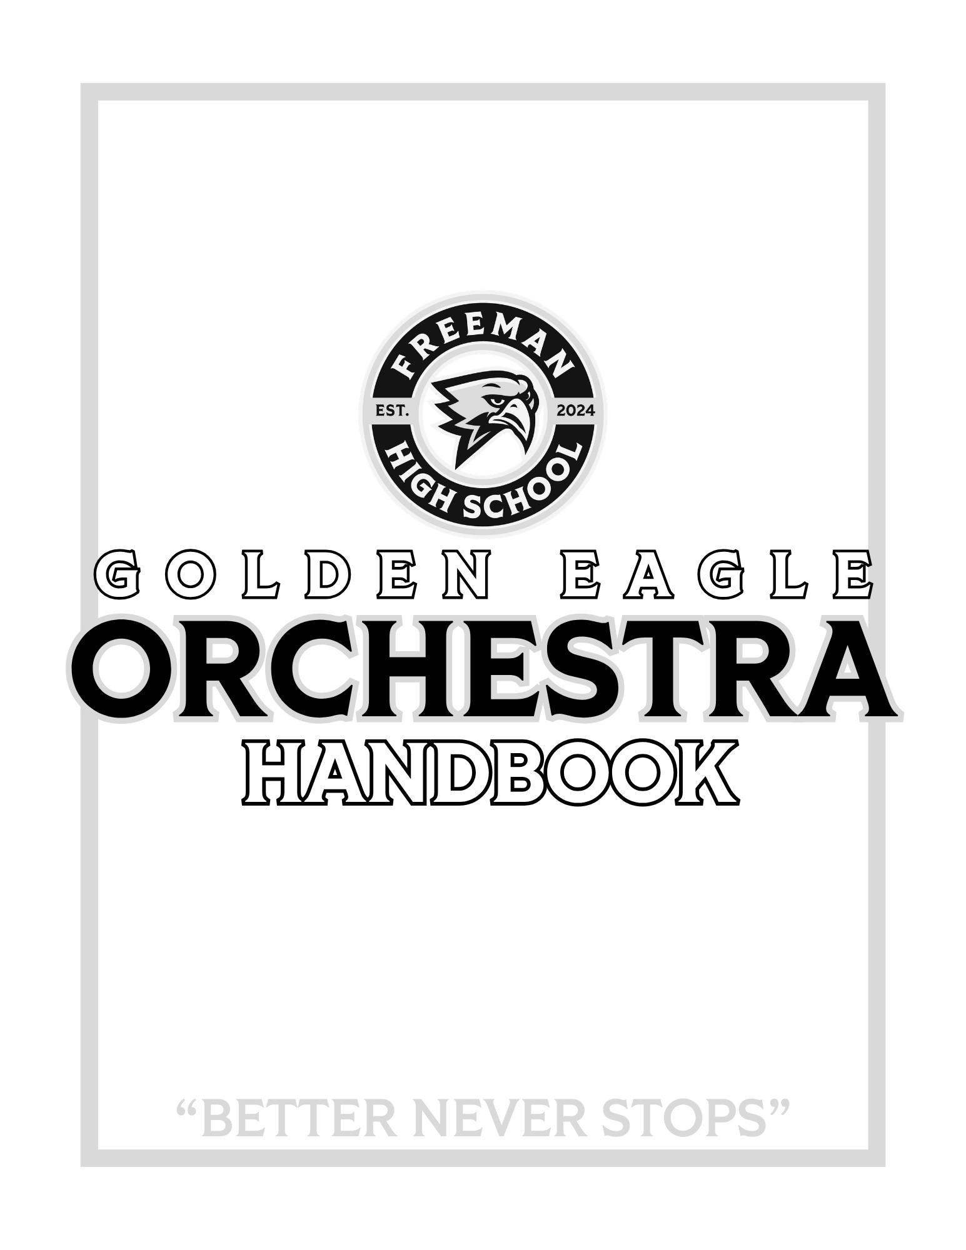

Introduction

Katy ISD is proud to offer a comprehensive music program that includes string instruction from grades 6 – 12. FHS Orchestra is a vital segment of the music curriculum. It is expected that members of the Freeman Orchestra will exhibit the highest possible standards in the following areas:

1. Responsibility 2. Dependability 3. Dedication 4. Musical Excellence

It is the goal of the director to promote musical understanding and produce outstanding orchestras. It is also the belief of the director that students learn more and develop better self-discipline, responsibility, and knowledge and take more pride in superior orchestras than in weak ones. To produce an outstanding orchestra requires that each student accept certain responsibilities.

Purpose

The Freeman High School Orchestra is a class that meets for one forty-five minute period each school day. The nature of this class requires the development of skills, concepts, and attitudes to be learned in class. These must, however, be demonstrated outside of class via many varied forms of rehearsals and performances. Along with your musical growth, we expect to see development in the areas of leadership, self-discipline, responsibility, teamwork, and a deeper appreciation for the beauty and joy that music offers to all who partake in it.

Conduct

The behavior of an orchestra student reflects not only on themself, but also on other students and their school and
community. It is expected that each orchestra student abide by the following at all times:

- Make a positive contribution to the FHS Orchestras;
- Display common courtesy and respect to all adults and peers;
- Follow expectations as outlined by the orchestra directors below;
- Follow rules and policies outlined in the KISD and FHS Student Handbooks.

Director of Orchestras

Welcome to the 2026 - 2027 Golden Eagle Orchestra! With our first graduating class embarking on their senior year, this is sure to be one of the most pivotal years of our program’s growth. Every member of the orchestra can look forward to ways to get involved, be surrounded by the absolute best people Freeman has to offer, and immerse themselves in amazing repertoire.

Please refer to this handbook and its policies for any information you need. Additionally, I will send out a six-week newsletter that is posted on the orchestra website for more specific details. If you have any questions, please feel free to reach out! Because I am often not at my desk, the best way to reach me is through email.

Looking forward to an exceptional year!

Jennifer Gingell
281-234-6770
JenniferFGingell@katyisd.org
FreemanOrchestras.com

Classroom Expectations

- Candy, gum, food, and/or drink are not allowed in any area within the orchestra rehearsal space. Water is permissible as long as it does not distract from the rehearsal.
- Speak or play only when invited.
- Bring your instrument, music binder, and all necessary supplies to class each day.
- Fingernails must be kept short, as it is not possible to play a stringed instrument with long nails (even moderately long nails). Keeping nails short is a requirement for all FHS Orchestra members. Acrylic nails are permissible; however, they must be filed to a short length. Students out of compliance with this rule will not be able to participate for the day. For special events, please be in contact with the director before nails are applied.

Grades

- 50% Major Grades
  - A form of written or playing test will be given most weeks
    - Canvas submissions will follow the school late grade policy. During assignments that require the student to use a video camera, students should dress appropriately within the school dress code.
  - All performances
- 35% Minor Grades
  - Ensemble Rehearsal Skills (being an active member of class performance and discussion)
    - Students begin with 100 points each week; however, points will be deducted for: supplies not brought to class, lack of effort, disruptive class behavior/talking, and not following classroom expectations.
  - Quizzes
- 15% Other Grades
  - Practice Journals
    - The amount of time your child spends practicing each day is entered on the weekly practice journal that is kept in their Orchestra Binder. Journals are due every Tuesday. Failure to have a parent signature or a completed journal on these days will result in a grade of zero.
    - All practice journals must be recorded on the official practice journal.
    - Practice minutes may not include rehearsals, sectionals, or any musical concerts. Minutes may include private lessons.

Academic Eligibility

A student shall be suspended from participation in all extra-curricular activities during the six-weeks period following a grade reporting period in which the student received a grade lower than 70 in any class on their report card. This ineligibility begins seven days after the end of the six weeks period. Events affected by this state law would include Solo and Ensemble, Region, and any event where admission is charged. Ineligible students are required to participate in concerts where no admission is charged. An ineligible student may regain eligibility seven days after the grading period ends or after the Progress Report if all classes are passing with a grade of 70 or higher.

Before/After School Rehearsals

An orchestra performs at its optimum with all members present; therefore, students are required to participate in all rehearsals, sectionals, and performances. An orchestra calendar is available online and given to each student to keep in their orchestra binder. Sectionals, extra rehearsals, concerts, contests, and UIL Concert and Music Literacy Evaluations are considered an extension of the classroom instruction and are considered co-curricular by the district.

The Freeman Orchestras meet during separate class periods each day, so it is necessary that selected groups rehearse outside of the school day. These rehearsals are the only times in which we rehearse as a full group or prepare for our concerts. Students may have scheduled rehearsals at the discretion of the director; advance notification will be provided for students to plan ahead.

Absence Policy

- Written notices, using the Absence Notification Form, are required for all absences for before and after-school events.
Verbal notice, emails, and/or written notes from students will not be accepted and will be considered unexcused.

- Advance notices are required for all prior commitments. A prior commitment is defined as an event already committed to before the orchestra time schedule is announced. A notice of such a commitment should be sent to the director the next school day after a date is announced.

- Doctor, orthodontist, dental, eye, etc. appointments are unexcused during scheduled events outside of regular classes. These appointments are considered routine and will not result in an excused absence unless your child is unexpectedly ill.

- In the case of illness and/or family emergency, parents should send a written notice or email to the orchestra director as soon as they are aware that such a situation exists. If in the emergency situation it is not possible to get in touch quickly, please follow up with a written note within four days after the fact. This is the only category where absences will be excused the same day or after the event.

- Religious holidays or conflicts with individual religious beliefs are considered excused if the director is notified the next school day after a date is announced.

- Students who enroll in other school activities such as athletics, choir, drama, etc., must plan ahead to avoid conflict. The orchestra director will work together with the other teachers, coaches, and directors of these activities to give each student every opportunity to be a part of other groups. Non-school sponsored activities will not be excused for any reason.

- Although it would be impossible to include a complete list, the following items are other examples of unexcused absences:
  - Commitments accepted after a rehearsal or concert date is announced;
  - Homework;
  - Lack of planning in regards to transportation;
  - Forgetting instrument and/or music;
  - Forgetting about a rehearsal or concert.

In order to encourage regular attendance at scheduled events, the following policies will take place:
- Any absence from an event without a note from the parent/guardian will be considered unexcused unless prior arrangements have been made with the director. The grade for the event will be a zero.
- Failure to meet the attendance requirements for orchestra can result in a student losing the privilege of traveling with the orchestra on any extracurricular trips.
- Unexcused tardiness will result in the lowered grade for that event.
- Any absence that is excused will be accompanied by an alternate assignment to make up the grade for the event.

Please communicate directly with the orchestra director if there are individual or unusual circumstances that may be a problem. Good communication between parents and teachers can prevent misunderstandings!

Supply List

- INSTRUMENT
  - Correctly sized by the director
  - Good condition
    - Due to the overwhelming amount of mechanical problems of these instruments, the following “brands” are not accepted in the FHS Orchestra program: Cecilio, Eastar, and Medina
  - Carbon fiber or wood bow strongly recommended
  - Rosin
  - Good quality strings on instrument (Red Label or wire strings are not allowed)
  - Extra set of strings inside of the case (violin and viola only)
- BINDER (1” Black Viewfinder)
  - 2 Pencils
  - Highlighter
  - Pencil Pouch
  - Dividers
- SHOULDER REST (violin and viola only)
- ROC STOP (cello and bass)
- TUNER and METRONOME (Recommended: Korg TM-50 with tuning clip; Tonal Energy App)
- SOFT CLOTH
- WIRE STAND
- UNIFORM, INFORMAL AND FORMAL

Orchestra Uniforms

For all concerts, students will wear the appropriate uniform. Part of each performance grade will be based upon how
you wear your uniform - neatness, alterations, cleanliness, etc. If there are any alterations needed to make your uniform look better, you may have them done if they are temporary alterations, and no fabric is cut AT ALL! If any fabric is cut, the student is responsible for the cost of replacing the uniform. The formal uniforms are provided by the school district, except for button-down shirt, socks, hosiery, and shoes. Under no circumstance is anyone allowed to wear boots, tennis shoes, or sandals of any kind with their formal uniform. Informal uniform shirts will be covered in the orchestra fee.

- Formal Concert Uniform
  - Option 1 - Dress Uniform: black dress, black hosiery (when appropriate), and black, closed-toe dress shoes. Any jewelry worn must be simple; excessive or large jewelry will hinder performance abilities.
  - Option 2 - Tuxedo Uniform: black tuxedo, gold tie, black button-down dress shirt, black socks, and black, closed-toe dress shoes. Any jewelry worn must be simple; excessive or large jewelry will hinder performance abilities.
- Informal Uniform
  - Current FHS Orchestra tee-shirt with long jeans and closed-toed shoes.

Equipment and Lockers

Students are expected to bring their orchestra binder to every orchestra class and co-curricular event. Violin and viola players must bring their shoulder rest, rosin, and soft cloth every day to class. All personal instruments MUST have the student’s name clearly printed on the outside of the case.
- Lockers:
  - Students may only use the locker that is specifically assigned to them.
  - It is the responsibility of the student to keep their locker organized and clean.
  - Personal instruments (violins/violas) and binders may be placed in your locker. Students should only keep items that are necessary for orchestra in their orchestra lockers.
  - Cello/Bass students may share a locker with others; students may not keep “extra” items in assigned lockers.
  - Students may not keep any food or drink in their lockers.
  - After class, all instruments should be completely packed (end pins in, bows loosened, and cleaned) and stored in their assigned areas for safe-keeping.
  - Instruments may not stay at school overnight; it is required that every violin, viola, and binder goes home every day. This policy includes leaving an instrument over a long break, such as Thanksgiving or Winter Break.
  - Students who have two instruments must provide parent verification to leave their secondary instrument overnight.
Violations of any of the above rules can result in loss of locker privileges. Orchestra directors will conduct periodic inspections of lockers to ensure they are clean and that instruments are taken home. Failure to abide by the aforementioned rules will result in loss of points from the daily grade as well as loss of locker privileges.
- Repairs:
  - All instruments are to be in good playing condition. Proper maintenance is required. Most shops will provide a “loaner” instrument while yours is being repaired should it need to be left in the shop.
  - Students are to purchase replacement strings immediately following a string breaking. Lisle Violin, Sam’s Strings, and Katy Violin can arrange to bring supplies (like strings) you purchase to school for no extra charge.
  - Many times minor adjustments can be made by the director which may eliminate a trip to the repair shop, so should you have any questions please consult the orchestra director. Please do not attempt to repair the instrument yourself. Neglecting a repair may lead to long-term damage and depreciation in the value of the instrument.

Private Lessons

Private lessons are offered by the Katy ISD Fine Arts Program to instrumental music students who are interested. These teachers’ dedication and service to our orchestra program is exemplary and worthy of your consideration. Space with these teachers is limited and openings do fill up quickly.

There are also instructors in the area who do not teach in the KISD Fine Arts Program. These fine teachers may request that you travel to their home or studio. In any case where the lesson does not take place on a KISD campus, payments are scheduled between the student and the instructor.

Although your child receives valuable instruction in our classes, private lessons provide:
- Students with an opportunity to deal with the unique challenges of the particular instrument one-on-one with an expert teacher. This will allow them to progress at their own level at all times rather than at the rate of the class.
- Review and reinforcement of class assignments when necessary.
- Earlier exposure to techniques such as vibrato, advanced bowing, shifting, and intonation.
- Expanded opportunities for advanced solo and ensemble instruction.
- Greater confidence in their individual performance because of the individual attention that private lessons provide.
- Enhanced opportunity for success at individual competitions such as All-Region Orchestra and Solo & Ensemble Contest.
- Heightened standard for group endeavors such as concerts and contests.

Private lessons are not required but are one of the best investments in a student's success!

25-26
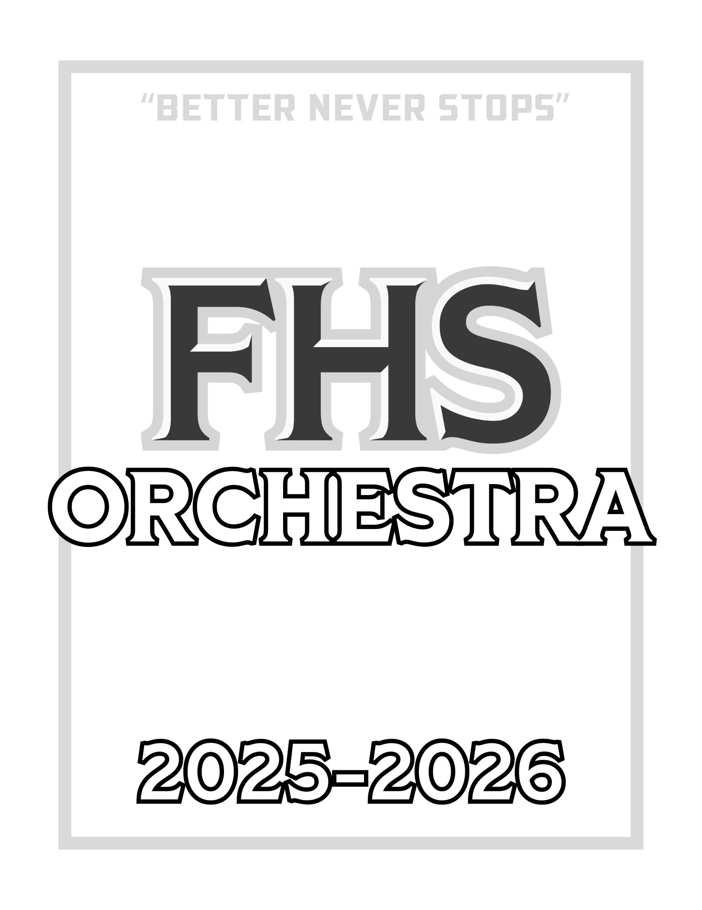

Introduction

Katy ISD is proud to offer a comprehensive music program that includes string instruction from grades 6 – 12. FHS Orchestra is a vital segment of the music curriculum. It is expected that members of the Freeman Orchestra will exhibit the highest possible standards in the following areas:

1. Responsibility 2. Dependability 3. Dedication 4. Musical Excellence

It is the goal of the director to promote musical understanding and produce outstanding orchestras. It is also the belief of the director that students learn more and develop better self-discipline, responsibility, and knowledge and take more pride in superior orchestras than in weak ones. To produce an outstanding orchestra requires that each student accept certain responsibilities.

Purpose

The Freeman High School Orchestra is a class that meets for one forty-five minute period each school day. The nature of this class requires the development of skills, concepts, and attitudes to be learned in class. These must, however, be demonstrated outside of class via many varied forms of rehearsals and performances. Along with your musical growth, we expect to see development in the areas of leadership, self-discipline, responsibility, teamwork, and a deeper appreciation for the beauty and joy that music offers to all who partake in it.

Conduct

The behavior of an orchestra student reflects not only on themself, but also on other students and their school and
community. It is expected that each orchestra student abide by the following at all times:

- Make a positive contribution to the FHS Orchestras;
- Display common courtesy and respect to all adults and peers;
- Follow expectations as outlined by the orchestra directors below;
- Follow rules and policies outlined in the KISD and FHS Student Handbooks.

Director of Orchestras

Welcome to the 2025 - 2026 Freeman Orchestra! I am so excited to work with our Golden Eagle Orchestra team to continue making beautiful sounds and building our traditions. This year will provide many opportunities for students to grow as musicians, get involved, and have an exceptional experience at Freeman High School.

Please refer to this handbook and its policies for any information you need. Additionally, I will send out a monthly newsletter that is posted on the orchestra website for more specific details. If you have any questions, please feel free to reach out! Because I am often not at my desk, the best way to reach me is through email.

Looking forward to an amazing year!

Jennifer Gingell
281-234-6770
JenniferFGingell@katyisd.org
FreemanOrchestras.org

Classroom Expectations

- Candy, gum, food, and/or drink are not allowed in any area within the orchestra rehearsal space. Water is permissible as long as it does not distract from the rehearsal.
- Speak or play only when invited.
- Bring your instrument, music binder, and all necessary supplies to class each day.
- Fingernails must be kept short, as it is not possible to play a stringed instrument with long nails (even moderately long nails). Keeping nails short is a requirement for all FHS Orchestra members. Acrylic nails are permissible; however, they must be filed to a short length. Students out of compliance with this rule will not be able to participate for the day. For special events, please be in contact with the director before nails are applied.

Grades

- 50% Major Grades
  - A form of written or playing test will be given most weeks
    - Canvas submissions will follow the school late grade policy. During assignments that require the student to use a video camera, students should dress appropriately within the school dress code.
  - All performances
- 35% Minor Grades
  - Ensemble Rehearsal Skills (being an active member of class performance and discussion)
    - Students begin with 100 points each week; however, points will be deducted for: supplies not brought to class, lack of effort, disruptive class behavior/talking, and not following classroom expectations.
  - Quizzes
  - Practice Planner Content
- 15% Other Grades
  - Practice Planner Minutes
    - The amount of time your child spends practicing each day is entered on the weekly practice planner that is kept in their Orchestra Binder. Planners will be graded every Tuesday. Failure to have a parent signature or a completed planner on these days will result in a grade of zero.
    - All practice planners must be recorded on the official practice planner. Practice minutes may not include rehearsals, sectionals, or any musical concerts.
  - Crew Requirements

Academic Eligibility

A student shall be suspended from participation in all extra-curricular activities during the six-weeks period following a grade reporting period in which the student received a grade lower than 70 in any class on their report card. This ineligibility begins seven days after the end of the six weeks period. Events affected by this state law would include Solo and Ensemble, Region, and any event where admission is charged. Ineligible students are required to participate in concerts where no admission is charged. An ineligible student may regain eligibility seven days after the grading period ends or after the Progress Report if all classes are passing with a grade of 70 or higher.

Before/After School Rehearsals

An orchestra performs at its optimum with all members present; therefore, students are required to participate in all rehearsals, sectionals, and performances. An orchestra calendar is available online and given to each student to keep in their orchestra binder. Sectionals, extra rehearsals, concerts, contests, and UIL Concert and Music Literacy Evaluations are considered an extension of the classroom instruction and are considered co-curricular by the district.

The Freeman Orchestras meet during separate class periods each day, so it is necessary that selected groups rehearse outside of the school day. These rehearsals are the only times in which we rehearse as a full group or prepare for our concerts. Students may have scheduled rehearsals at the discretion of the director; advance notification will be provided for students to plan ahead.

Absence Policy

- Written notices from parents/adults are required for all absences for before and after school events. Verbal or written notices from students will not be accepted.

- Advance notices are required for all prior commitments. A prior commitment is defined as an event already committed to before the orchestra time schedule is announced. A notice of such a commitment should be sent to the director the next school day after a date is announced.

- Doctor, orthodontist, dental, eye, etc. appointments are unexcused during scheduled events outside of regular classes. These appointments are considered routine and will not result in an excused absence unless your child is unexpectedly ill.

- In the case of illness and/or family emergency, parents should send a written notice or email to the orchestra director as soon as they are aware that such a situation exists. If in the emergency situation it is not possible to get in touch quickly, please follow up with a written note within four days after the fact. This is the only category where absences will be excused the same day or after the event.

- Religious holidays or conflicts with individual religious beliefs are considered excused if the director is notified the next school day after a date is announced.

- Students who enroll in other school activities such as athletics, choir, drama, etc., must plan ahead to avoid conflict. The orchestra director will work together with the other teachers, coaches, and directors of these activities to give each student every opportunity to be a part of other groups. Non-school sponsored activities will not be excused for any reason.

- Although it would be impossible to include a complete list, the following items are other examples of unexcused absences:
  - Commitments accepted after a rehearsal or concert date is announced;
  - Homework;
  - Lack of planning in regards to transportation;
  - Forgetting instrument and/or music;
  - Forgetting about a rehearsal or concert.

In order to encourage regular attendance at scheduled events, the following policies will take place:
- Any absence from an event without a note from the parent/guardian will be considered unexcused unless prior arrangements have been made with the director. The grade for the event will be a zero.
- Failure to meet the attendance requirements for orchestra can result in a student losing the privilege of traveling with the orchestra on any extracurricular trips.
- Unexcused tardiness will result in the lowered grade for that event.
- Any absence that is excused will be accompanied by an alternate assignment to make up the grade for the event.

Please communicate directly with the orchestra director if there are individual or unusual circumstances that may be a problem. Good communication between parents and teachers can prevent misunderstandings!

Supply List

- INSTRUMENT
  - Correctly sized by the director
  - Good condition (due to the mechanical problems of these instruments, Cecilio, Eastar, and Medina instruments are not accepted in the FHS Orchestra program)
  - Carbon fiber or wood bow strongly recommended
  - Rosin
  - Good quality strings on instrument (Red Label or wire strings are not allowed)
  - Extra set of strings inside of the case (violin and viola only)
- BINDER (1” Black Viewfinder)
  - 2 Pencils
  - Highlighter
  - Pencil Pouch
  - Dividers
- SHOULDER REST (violin and viola only)
- ROC STOP (cello and bass)
- TUNER and METRONOME (Recommended: Korg TM-50 with tuning clip; Tonal Energy App)
- SOFT CLOTH
- WIRE STAND
- UNIFORM, INFORMAL AND FORMAL

Orchestra Uniforms

For all concerts, students will wear the appropriate uniform. Part of each performance grade will be based upon how
you wear your uniform - neatness, alterations, cleanliness, etc. If there are any alterations needed to make your uniform
look better, you may have them done if they are temporary alterations, and no fabric is cut AT ALL! If any fabric is cut,
the student is responsible for the cost of replacing the uniform. The formal uniforms are provided by the school district,
except for button-down shirt, socks, hosiery, and shoes. Under no circumstance is anyone allowed to wear boots, tennis shoes, or sandals of any kind with their formal uniform. Informal uniform shirts will be covered in the orchestra fee.

- Formal Concert Uniform
  - Option 1 - Dress Uniform: black dress, black hosiery (when appropriate), and black, closed-toe dress shoes. Any jewelry worn must be simple; excessive or large jewelry will hinder performance abilities.
  - Option 2 - Tuxedo Uniform: black tuxedo, gold tie, black button-down dress shirt, black socks, and black, closed-toe dress shoes. Any jewelry worn must be simple; excessive or large jewelry will hinder performance abilities.
- Informal Uniform
  - Current FHS Orchestra tee-shirt with long jeans and close-toed shoes.

Equipment and Lockers

Students are expected to bring their orchestra binder to every orchestra class and co-curricular event. Violin and viola players must bring their shoulder rest, rosin, and soft cloth every day to class. All personal instruments MUST have the student’s name clearly printed on the outside of the case.
- Lockers:
  - Students may only use the locker that is specifically assigned to them.
  - It is the responsibility of the student to keep their locker organized and clean.
  - Personal instruments (violins/violas) and binders may be placed in your locker. Students should only keep items that are necessary for orchestra in their orchestra lockers.
  - Cello/Bass students may share a locker with others; students may not keep “extra” items in assigned lockers.
  - Students may not keep any food or drink in their lockers.
  - After class, all instruments should be completely packed (end pins in, bows loosened, and cleaned) and stored in their assigned areas for safe-keeping.
  - Instruments may not stay at school overnight; it is required that every violin, viola, and binder goes home every day. This policy includes leaving an instrument over a long break, such as Thanksgiving or Winter Break.
  - Students who have two instruments must provide parent verification to leave their secondary instrument overnight.
Violations of any of the above rules can result in loss of locker privileges. Orchestra directors will conduct periodic inspections of lockers to make sure they are clean, and to make sure instruments are taken home. Failure to abide by the aforementioned rules will result in loss of points from daily grade as well as loss of locker privileges.
- Repairs:
  - All instruments are to be in good playing condition. Proper maintenance is required. Most shops will provide a “loaner” instrument while yours is being repaired should it need to be left in the shop.
  - Students are to purchase replacement strings immediately following a string breaking. Lisle Violin, Sam’s Strings, and Katy Violin can arrange to bring supplies (like strings) you purchase to school for no extra charge.
  - Many times minor adjustments can be made by the director which may eliminate a trip to the repair shop, so should you have any questions please consult the orchestra director. Please do not attempt to repair the instrument yourself. Neglecting a repair may lead to long term damage and depreciation in the value of the instrument.

Private Lessons

Private lessons are offered by the Katy ISD Fine Arts Program to instrumental music students that are interested. These teachers’ dedication and service to our orchestra program is exemplary and worthy of your consideration. Space with these teachers is limited and openings do fill up quickly.

There are also instructors in the area that do not teach in the KISD Fine Arts Program. These fine teachers may request that you travel to their home or studio. In any case where the lesson does not take place on a KISD campus, payments are scheduled between the student and the instructor.

Although your child receives valuable instruction in our classes, private lessons provide:
- Students with an opportunity to deal with the unique challenges of the particular instrument one-on-one with an expert teacher. This will allow them to progress at their own level at all times rather than at the rate of the class.
- Review and reinforcement of class assignments when necessary.
- Earlier exposure to techniques such as vibrato, advanced bowing, shifting, and intonation.
- Expanded opportunities for advanced solo and ensemble instruction.
- Greater confidence in their individual performance because of the individual attention that private lessons provide.
- Enhanced opportunity for success at individual competitions such as All-Region Orchestra and Solo & Ensemble Contest.
- Heightened standard for group endeavors such as concerts and contests.

Private lessons are not required but are one of the best investments in a student's success!

